Security Collaboration
Good Practices

InterAction Security Unit

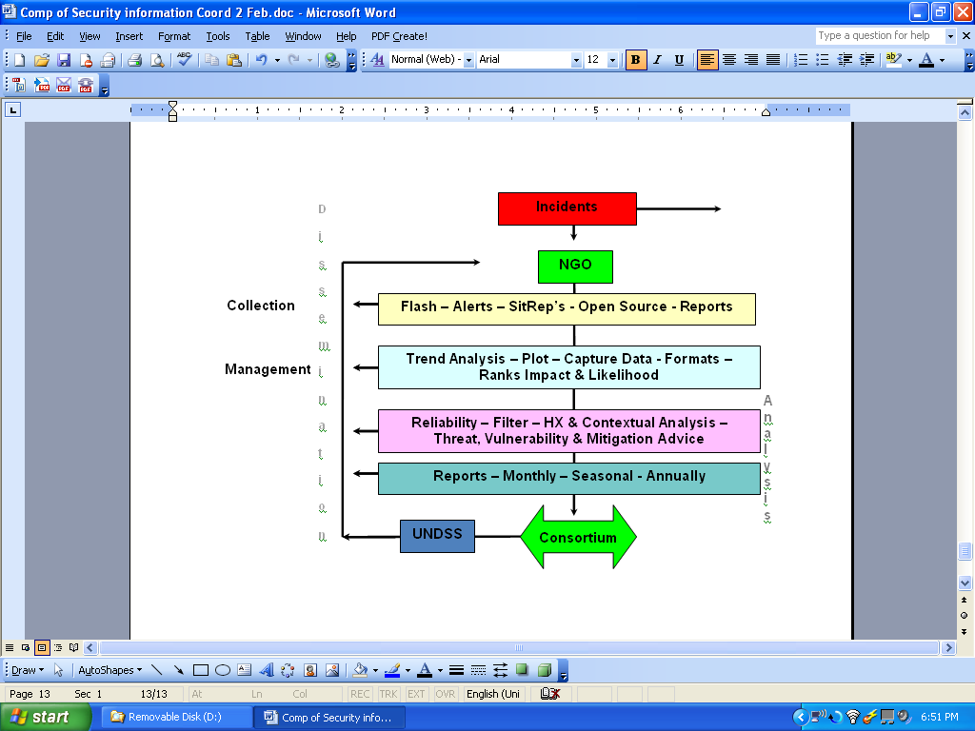



Table of Contents

Reference Collaboration
Intent
Goal
Horizontal and Vertical Communications

Types of Field Collaboration
Existing Collaboration
Informal
Intermediate
Full Spectrum
Source reliability
Collection, Management and Dissemination

The Security Report
The United Nations DSS
Incident Plotting
Anomalies
Consortiums
Disasters
Conclusions
Acknowledgements

Annex 1 - Pakistan Informal
Annex 2 - SPAS Full Spectrum

3
4
4
4
5

5
6
6
6
7
8
9

11
12
13
14
15
16
17
18

19
23

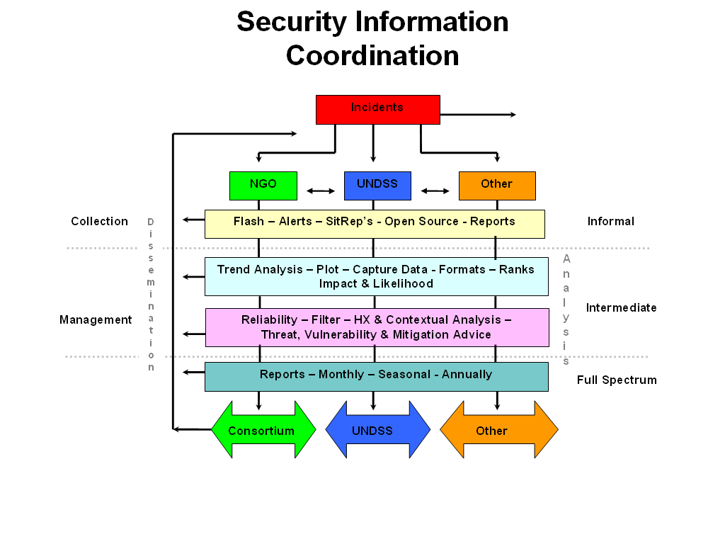

Reference:
Saving Lives Together: “Arrangements Among IGOs. NGOs and the UN in the Field” A Framework for improving Security Inter-Agency Standing Committee
66th Working Group Meeting

63/305 Safety and security of humanitarian personnel and protection of United Nations personnel

Interaction Security Unit Guidelines for ngo security risk management

Intent

The intent of this guide is to enhance security collaboration in the field, by defining the three types of security collaboration utilized by Non-Government Organizations (NGOs), International Organizations (IOs) and other stakeholders. Although each collaborative mechanism may have a diverse structure, we find that the services and products (or outputs) are often very similar. This guide will provide the security professionals a useful reference with a visual representation of three levels of security collaboration provides to the stake holders. This guide should be used in tandem with the ECHO NGO Security Collaboration Guide, 2006 (http://ec.europa.eu/echo/evaluation/security_review_en.htm), and must not replace the excellent work that provides advice on how to launch or improve collaborative initiatives.

Collaboration Definition

Security collaboration exists when two or more agencies are willing to act together to address a mutually identified security concern, in the belief that this will improve security information and support for their staff and, as a result, allow them to deliver assistance to beneficiaries more effectively.

Terms like ‘coordination’ and ‘collaboration’ have been used in a wide range of security initiatives in different contexts. While it is important not to labor over these definitions, it should be recognized that ‘coordination’ is often a controversial concept in the humanitarian sector; some NGOs resist coordination for fear of being ‘controlled’ or swamped by bureaucracy and restrictions. Recently there has been a shift in favor of a ‘collaborative’ approach to security in the field.

(ECHO Security Collaboration Guide, 2006)

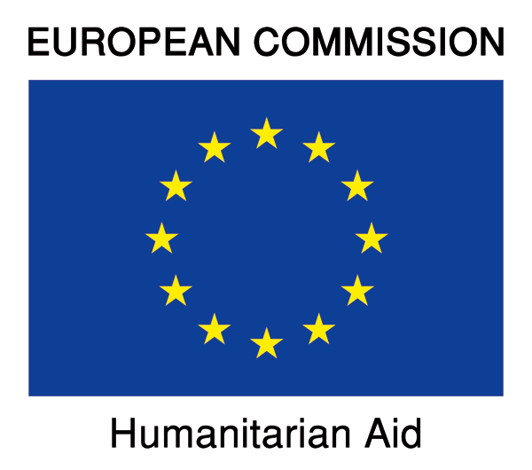

The Goal (visually modeled page 2)
The security collaboration network seeks to better facilitate the sharing of relevant information both horizontally and vertically. The ultimate goal of security collaboration is to have the collective community break down both vertical and horizontal barriers to better facilitate information sharing. The most expeditious means of accomplishing this goal is to establish security collaboration for those operating in environments of elevated risk. This paper will analyze security collaboration mechanisms output [dissemination]; visually map their processes and categorize them into either an informal, intermediate, or full-spectrum type of mechanism.

It is very difficult and almost impossible to properly provide analysis of a security situation without the collection and management of information. It is even more difficult to do it without a dedicated resource or focal point t to facilitate the process. As stakeholders begin to collaborate in a coordinated security effort the amount of information often looks like a high volume unregulated intersection. The focal point of collaboration becomes the “traffic light” of the information management process. The intersection is comprised of horizontal and vertical information networks in which stakeholders can tap into. When managed effectively the network can add clarity the threat image and provide better data for analysis. The stake holder can then interpret and compare the analysis to their individual Security Risk Assessment in order to adjust activities and/or locations of their programs. Organizations participating in the collaborative effort should value the products provided as equally as it values vertical and horizontal sharing of information. When a stakeholder in a region desires broader analysis, then a focal point of can be attached to the network enhancing the overall image of the security situation.

Horizontal and Vertical Communication
Horizontal communication is defined as information that is shared laterally (as shown in the graph above). For example, horizontal communication occurs when ’NGO A’ shares a security report with a forum or another NGO at the field level. Another example of horizontal communication would be when Security Director from ‘NGO A’ shares information with Security Director of ‘NGO B’ or a security consortium such as EISF or the InterAction SAG. Horizontal communication only has one element and it should be framed by the information security policy of the organization. As information is gathered by an organization in the form of a security incident report, the information security policy should act as a guide for determining which segments of a security incident report should not be shared (victim’s names and sometimes the stake holder identity). It is important to note that a security collaboration mechanism should have a security information policy that can assist in the sharing of information by acting as an oracle to assist in protecting the identity of a stakeholder that wished to share critical information and remain anonymous. When security incidents are not collected trends or shared horizontally information is difficult to vet, it is often unreliable and it forces stakeholders to make decisions with narrow analysis.

Vertical information is transmitted upwards (ascending) and downwards (descending) within the same silo, therefore it has two elements, ascending and descending. An example of ascending vertical information would be when an NGO headquarters or another stakeholder shares information for research, or outside analysis to a University. Another example of ascending information would be when a stakeholder in the region collects all of its incidents and sends them to its headquarters for a more detailed analysis. Organizations frequently find themselves operating in silos with limited access to pertinent security information. Vertical communication is then affected negatively because the breadth of information will be narrow, often leading to a more limited or incomplete analysis. Descending information would be when the analysis provided at the headquarters level sends it to the stakeholder in the region.

Optimal application of stakeholders utilizing the horizontal and vertical planes of communication are demonstrated when a Security Director from ‘NGO A’ consolidates information received a situation report he gains from his team in the field (vertical), and then shares it (horizontal) from to the Security Director of ‘NGO B’, who in turn the information to his team operating in the same location. The communication loop is then closed when the two field teams discuss the analysis and provide feedback to their Security Directors.

Security collaboration mechanisms thrive when both horizontal and vertical communication networks are ‘closing the loops’ and stakeholders are working in a coordinated fashion. This has been demonstrated successfully by ANSO in Afghanistan, and SPAS in Somalia which are both full-spectrum collaboration mechanisms

.

Diagonal Communication: An argument could be made that an additional plane of communication is diagonal in nature. For instance; if an NGO who is operating in the field were to observe a security incident and reports it directly to a consortium like the InterAction Security Unit or EISF, bypassing other stakeholders, then it would be diagonal communication.

Consortiums have had experiences in the past where an NGO vehicle was observed car-jacked. Those observing the incident did not have any means to communicate to the victims organization in the field so called the consortium, who passed the details to the NGO who was experiencing the situation.
Three Field Collaboration Types
Informal, Intermediate and Full Spectrum Security Collaboration
There are three types of security collaboration mechanisms occurring throughout the world that Non-Government Organizations (NGOs) organize, contribute to, receive information from, and participate with. These Security Collaboration structures provide a more coordinated approach to security than that of each organization working independently. The collaborative effort relies on the principle that the actions of every stakeholder of a community have an effect on the entire community. This approach also utilizes an underlying utopian theme that says “True security only exists when it is for the entire community.”

The foundation of collaboration is built on three pillars: Collection, Management, and Dissemination utilized in a coordinated fashion produce horizontal and vertical communication structures providing output adding value to organizations operating with a sense of community. When fused with a Source Reliability Matrix, it offers the community a methodology that enhances and enables them to more accurately measure unacceptable risks, identify mitigation options in their Security Risk Assessment and assist in developing a security budget for future activities based upon trend analysis.
Existing Field Collaboration
Many NGO collaboration mechanisms exist and each is unique (ANSO, GANSO, Darfur, BINGO, SPAS, CCO). We can evaluate and categorize the mechanisms by the output of each entity and the common elements that they share.

For the purposes of this document, collaboration will be assessed into categories based solely on output or information disseminated. The three types will be defined as Informal, Intermediate, and Full-Spectrum.

Informal Field Security Collaboration
An indicator of the informal security collaboration is that the dissemination [output] is basic in nature, such as a copy of an incident report, SMS text, alerts or flashes [often verbal], open source news reports and the sharing of rumors. Information that is provided between stake holders rarely has any vertical information input from HQs. The output at the informal level does not contain any written analysis, plotting of security incidents, standardized formats, source reliability, or seasonal reports. Given the above, there tends to be a formalized network of communication, commonly known as the telephone tree, which functions fairly well. A rotating chair is generally associated with an informal coordinating mechanism. The chair rarely has the same experience and/or training as a full-time security coordinator and the funding is often deficient or nonexistent. Combined with high turnover rates, the historical and contextual points of view tend to be shallow. The output provided varies from nothing at all to phone calls, conversations, text and email of warden messages, meeting notes, and other information gathered. Often due to the part-time nature of the rotation, the chair is over-burdened with the running of their own programming and balancing the security collaboration needs of the community.

Intermediate Field Security Collaboration
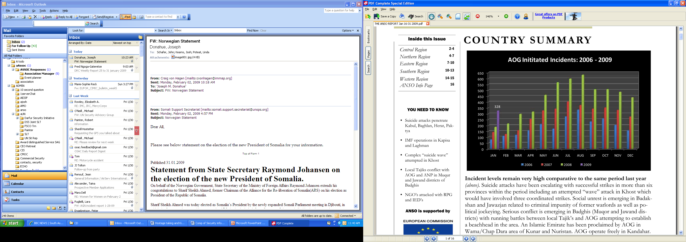Characteristics of Intermediate Collaboration include rudimentary trend analysis, basic plotting of incidents, open source collection, dissemination of security incidents and other reporting as needed. When funding is received and an effort to provide further analysis is just beginning, it would be difficult for the collaboration to be considered as a full-spectrum mechanism because the compilation of data will not provide the output with analysis deep enough to show seasonal or yearly trends. Often the contextual analysis is deficient in providing any information used in extrapolation of risk due to the rawness of the program.

Full Spectrum Field Security Collaboration
Characteristics of Full Spectrum Collaboration only occur after enough data has been gathered to determine seasonal and/or annual trends. Monthly, quarterly, seasonal, and annual reports are disseminated, releasing a sharper threat image which is commonly broken down by regions. Examples of Full Spectrum Collaboration include: the latest version of ANSO in Afghanistan (Example Below), SPAS in Somalia, and most common is the UN SIOC. Full-Spectrum is most frequently seen in regions with the greatest risk and it is becoming more common to see the humanitarian community work collaboratively to maximize resources.

The greatest difficulty in Full Spectrum Collaboration is that it cannot be implemented without full transparency and allowance of a particular host nation. In Pakistan, Gaza, and Sudan, efforts of NGO collaboration were prevented by government intervention. In the process, many of the NGOs participating and hosting the security collaboration were exposed to government retaliation, interrogation, and—in a few instances—physical abuse and expulsion from the country.

Often NGO security positions meet resistance from national interests and are restricted from operating in a country [in Sudan]. There are fewer barriers for the UN because it falls under the status of forces agreement. In Darfur, this situation has been resolved through the intervention of the UNDSS by assuming the sole funding, staffing, and operation of a Full Spectrum Collaboration. NGOs perform up to ninety percent of the UN operations in areas of Darfur.

Looking closely at the (actual) example to the above, we can predict that insecurity in Afghanistan in 2009 will continue to deteriorate. This data can be used for organizations that may choose to mitigate the increasing trend via programmed vacations during that time, or increased budgets to enhance protection, or by avoiding or stock piling in the most dangerous regions thereby reducing the likelihood.

Source Reliability Matrix (The Cycle)
Source Reliability
A  knowledgeable and has direct access to the information | B  knowledgeable but has no direct access to the information | C  usually reliable | D  usually not reliable |  |  | E  not reliable | F  cannot be assessed (We do not know) |  |  | O  Open Source  (Press)
Information Validity
1  Confirmed | 2  Not confirmed but probably true | 3  Not confirmed but possibly true |  | 4  Not likely | 5  Probably wrong information |  |  | 6 Unconfirmed (We do not know) |  | NFDK  No further details known
GNK  Grid not known; the location is not marked on available maps |  |  |  |  | FLASH  Current Activity |  |  |  | ALERT  Possible Future Events
SOURCE RELIABILTY MATRIX (InterAction)
A critical element that enhances a Full-Spectrum Security Collaboration mechanism is application of the Reliability and Validity Matrix (below) to information provided to a collaboration body’s end users. For instance, an "A" rating might mean a trusted source, such as vetted organizations contributing communications in order to collaborate fully with the collaboration operation. That source might be completely reliable.
An A1 (one) rating would indicate that the information was verified by a second - independent source.
Most reports are somewhere in the middle; a "B-2" is taken seriously. Sometimes, it is impossible to rate the reliability of source, most commonly from lack of experience with the individual reporting an incident, so an F-3 could be a reasonably probable report from an unknown source. An extremely trusted source might submit a report that cannot be confirmed or denied, so it would get an "A- 6" rating.

Using the model to the right, a security incident, may occur ( Collected) into the Collaboration Mechanism from an NGO that observes an incident that occurred to another NGO and then shared with the coordinating mechanism (shown as the arrow below the Red Incident Box).
Because the reporting NGO has provided reliable information previously and it was observed by the NGO, it may be reported (Disseminated) in a SitRep (Situation Report) symbolized by the arrow left of the yellow box; with ‘B -2’ rating.
Later the actual incident might be corroborated by another NGO, thus upgrading the incident as an ‘A -1’. This is an example of how to fuse two systems (CMD Process and Source Reliability Matrix).
Source Reliability
In reports disseminated from the collaboration mechanism, a source’s validity can be rated. The rating is a composite reflecting experience with the source's historical reporting, the source's direct knowledge of what is being reported, and the source's understanding of the subject.

Information Validity
Separately from the source evaluation is the evaluation of the substance of the report. The first factor is plausibility, indicating that the information is suggested by multiple sources, not confirmed but suggested by a (single source), probably true, not likely, probably wrong, unconfirmed, and no further details known. (See Source Reliability Matrix)

Verifying Information
When it is difficult to evaluate a report, confirmation may be a responsibility of those reporting the incident, the analysts, and/or those reporting or collecting the information. In a large and complex community, this can be a difficult issue that contains numerous sensitivities—yet not impossible. In Afghanistan for instance, ANSO developed many relationships with the IOs, NGOs the UN, and other actors, and over time has proven not to reveal its sources. Sensitive information is filtered before it is shared so it does not add any additional harm to the organization that supplies it. ANSO also has been in the position to quiet situations in order to protect an organization from rumors and/or actual incidents that need to be not reported when lives may still be in jeopardy. In a cooperative or small system, things can be less formal and often faster.
Collection, Management and Dissemination
The foundation of Security Collaboration is built on the three pillars of Collection, Management and Dissemination.

Collection
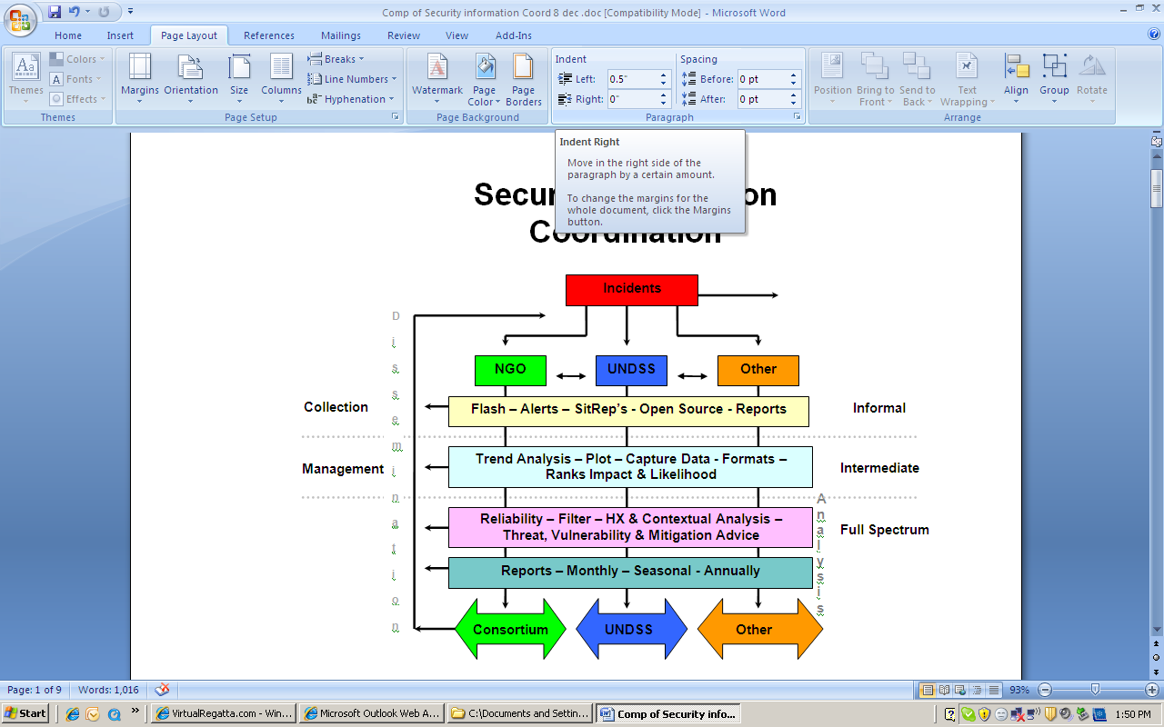(Highlighted right) Collection activities include these categories: post incident debriefings, liaison with other stake holders, security reports and shared incident reports, past and current mission analysis, formal and informal communications, open source mediums, and other sources with stakeholders. Activities supported by gathering information for the safety of NGOs are usually conducted by security focal points. Collection activities vary depending on the source of information. Once the types of information have been collected and prepared, the information has the potential to be shared horizontally with other stakeholders. This is often the initiating of the CMD Process.

Management of Information
(Represented in clear, right) Once the information has been collected, a single point of contact compiles, categorizes, plots and analyzes the data. The data includes information about the local civilian population including its political, ethnic, religious, cultural, tribal, economic, and other social components and how those factors relate to the security of humanitarian/NGO operations. It carefully examines the various stakeholders, security incidents, trends, and unique programming vulnerabilities. Additionally, the data can often provide predictive security analysis, assisting humanitarian organizations in developing future mitigation funding.

In addition to the above, the management pillar:

• Closely examines the current and potential threat to identify factors pertaining to the blend of acceptance, protection, deterrence and avoidance, production of a security risk assessment, training, and ideals that would affect both positively and negatively programming.
• Develops geographic information systems, social mapping, social networks data bases, and matrices, as required, to support the safety and security of humanitarian operations. These overlays may represent a wide variety of security issues, including mine information, host government infrastructure (for example, electrical power grid), population density, ethnic, religious, or tribal affiliation, and no-strike or collateral damage.

• Provides its products to stakeholders, and other consortiums.

Dissemination
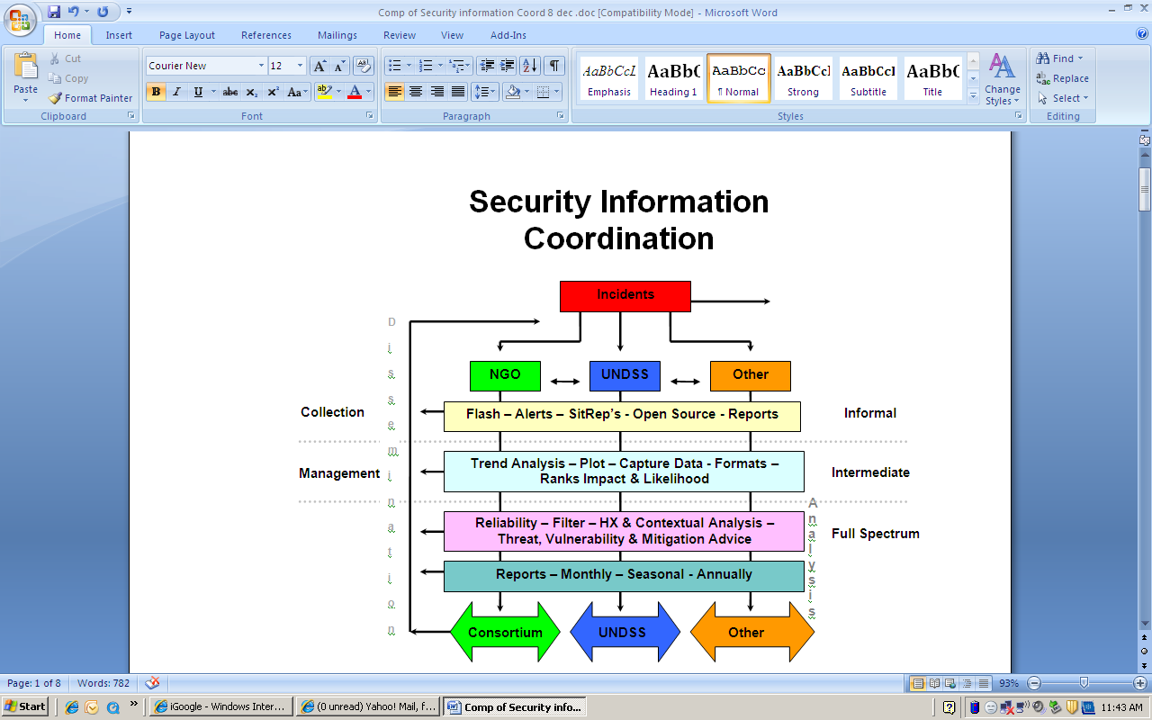(Highlighted right) Once information has been collected the Dissemination process begins. Mechanisms operating at the Informal Level of security collaboration often share information horizontally with other organizations in its raw form with little or no management of the information; and individual organizations often send the information vertically to their regional or headquarters. Analysis of the information is then done at a regional and headquarters level and not at the actual location of where the information was collected. The product (dissemination) provided to stake holders is rarely formatted and is often through verbal conversations, emails, or round table meetings with other stakeholders.

Dissemination provided in the Intermediate or Full Spectrum mechanisms utilize formal notes, graphs that identify trends, maps displaying areas of insecurity and other security related products. The management of the information is normally conducted in the same area that the mechanism is located. The produced materials are sent horizontally to other stakeholders and then the stakeholders send the synthesized product vertically to their regional and headquartered offices.

Where it all begins (The Report)
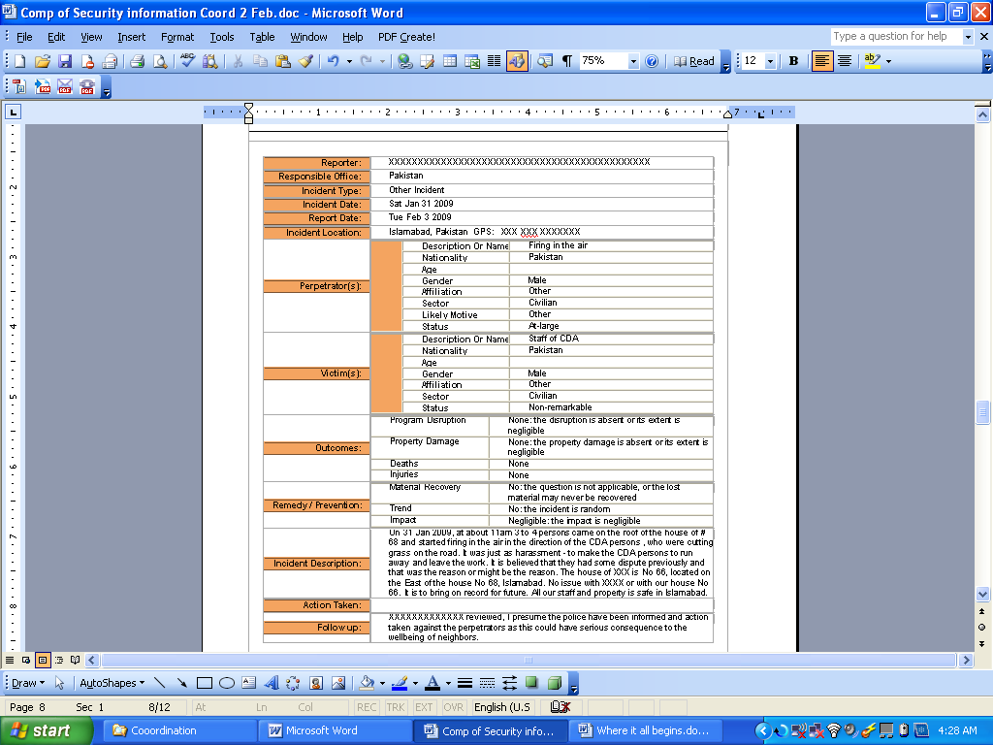
The most important and most critical element of the CMD process occurs soon after the incident. It is the actual report (record) that is filled out, specifying the particulars of the incident. (Example Right)

With as much detail as possible and in a written format, each incident needs to be recorded in a manner similar to the example on the right. This includes the type of incident, description, impact, victim, location, effect on programming, and the regular date, time, etc.

Although an initial verbal report may suffice, the written report has many internal and external functions and serves as the basis for Information Collaboration.

Internal Uses
NGOs need to maintain the data of incidents in order to assist them in managing the risk associated with the exposures that they assume. Such reports enable them to follow up on any HQ support in the form of counseling. Additionally, they may need the report for insurance purposes, internal tracking, country briefing, and even for training purposes.

External Uses
A sanitized version of the report can be shared with the community in order to provide better contextualized analysis, plotting of the incident, trend analysis, and in mitigation—advice. Often a coordinator in the specific location can be used as a mediator with a local authority to raise issues that may be particular to an incident that occurred to an NGO without singling out the NGO that may have a concern with an incident.

Incidents
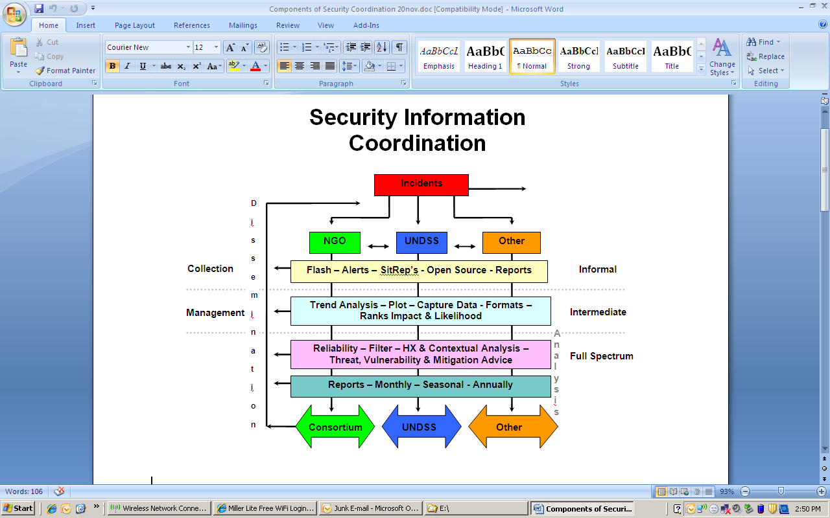The arrow on the right of the Red Incident Box represents the security incidents that are not reported. Stakeholders who reported incidents are represented by black arrows that descend from the incident box, thus initiating the flow of information.

Stakeholders
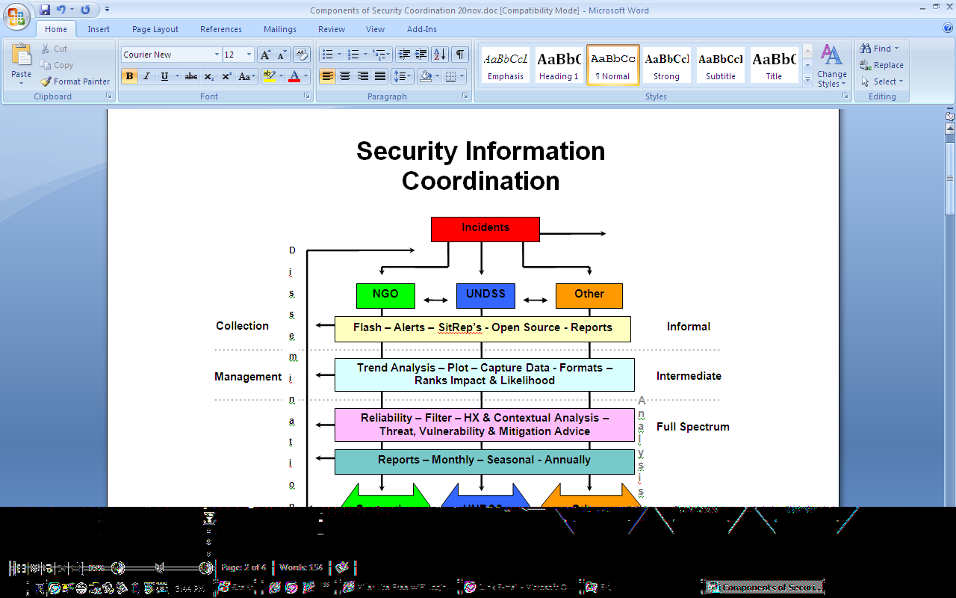An incident that occurs to a stakeholder is often reported to the local office in the area of operations. Sometimes other stakeholders observe the same incident and it enters into the CDM process through other means. For example, an attempted carjacking of one NGO may be observed and reported by another, resulting in the incident entering into the collaboration mechanism. It may be observed (or verbally disclosed) by one stakeholder and then shared in a meeting or via text and email. In the Informal Collaboration, there are times when there is not a standardized and the report is given verbally, emailed, or texted.

There are arrows that are horizontally displayed in-between the stakeholders which represent information that is shared at the field and country office level. For example, the arrows symbolize the efforts of when a security focal point of an NGO provides the UNDSS details of the incident. The UNDSS would then be able to include that information into its own system of CMD process assisting the UN in developing a more focused threat image.

The United Nations Department of Safety and Security (UNDSS) (Dissected)
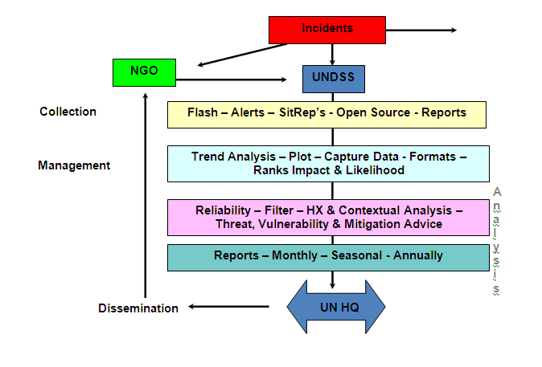
Often seen in the Collaboration Model is the UNDSS approach to security management. As a stakeholder in many areas, the UN frequently has a Full Spectrum Mechanism in place. Incidents to NGOs are included by the Field Coordinating Security Officer (FSCO) in the collection process in order to gain a more focused and accurate threat image. Through “Saving Lives Together” FSCOs assist NGOs with briefings, advice and other services when feasible, and on a cost recovery basis when requested.

‘Saving Lives Together’ (SLT) has been a significant move forward in collaboration between NGOs and the UN as a solidified policy. SLT assists in the sense of community as mentioned above.

There are many locations that also have other stakeholders that have applied Full Spectrum Collaboration Models. Third country interests, commercial entities (extraction industries), and development organizations are often other stakeholders that will have a Full Spectrum Information collaboration, however there is not any formal agreement that assists in sharing information.

Finally, Foreign Governments and Security Forces are most likely NOT to share anything with stakeholders at all. The irony of this model is that Foreign Governments who have the resources, assets, and access to much of the information in the management process classify the information and do not share it with the organizations to which they often donate. One remedy to this problem is that a separate risk assessment should always be maintained as an unclassified document when it pertains to the safety of humanitarians operating in a specific theatre.

Incident Plotting
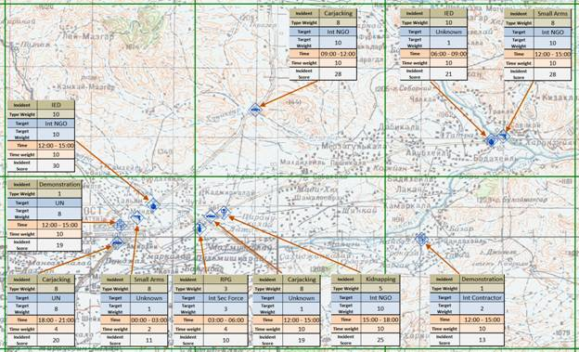
Incident plotting as the name implies is simply recording incident locations (georefrencing) so that they can be plotted on a map. The specific requirements for plotting incidents on a map will vary depending on theater of operation so specific details will not be covered in this document.

In general terms determining the location of an incident (not well defined at this point) can be accomplished through a variety of methods including GPS, digitizing from a digital map, map resection or address matching. Regardless of the specific method used it is important that the following items be widely agreed on by all actors that intend to contribute georeferenced incident data to the security effort.

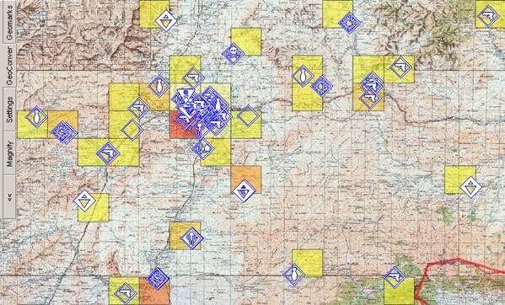
Geographic Coordinate Systems
A geographic coordinate system enables every location on the Earth to be specified. There are many different coordinate systems, based on a variety of geodetic datums, units, projections, and reference systems in use today. Generally its best to choose one coordinate system for reporting incident coordinates. It is possible to use more than one coordinate system however, this requires that each set of coordinates also be accompanied by data indicating coordinate system used, datum, units and projection.

From Paper to Digital Map
In order to plot an incident location on a digital map most modern Geographic Information Systems (GIS) require all coordinates be converted to latitude and longitude using decimal degrees. Storing coordinate data in this format allows GIS software to project coordinates to any other coordinate system required. The importance of the transition from analog (paper) to digital (GIS) cannot be understated. Once coordinates are converted to the correct digital format, the number and type of analysis options increase to include virtually all database operations (query, sorting, grouping) and GIS operations (spatial analysis, data integration, map production).
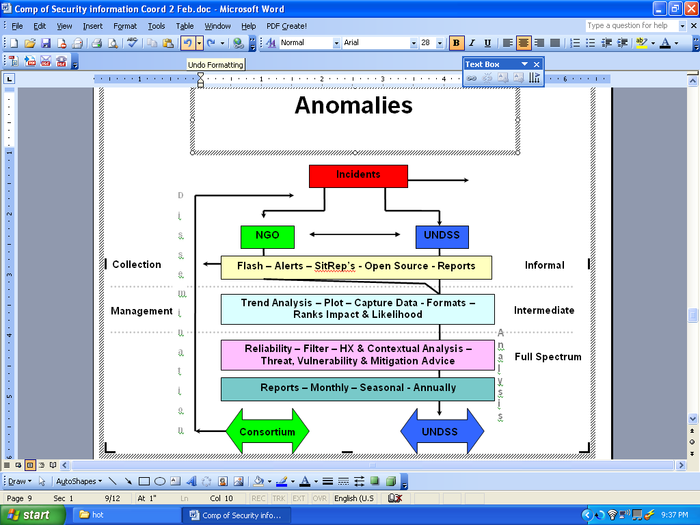

Anomalies
Detailed to the right is the model currently used in Darfur. Restrictions by the government of Sudan prohibit NGOs from utilizing the Intermediate or Full Spectrum Models. NGOs initiated one attempt to assist the community in managing the risks they face by starting their own collaboration in 2006. However the Sudanese Government intervened by stating NGO involvement was not appropriate. In 2008, the UN, ECHO, InterAction, and USAID initiated a modified Information Collaboration Model based on SLT. Under the permission of the Sudanese Government and operating under a Status of Forces Agreement, the UN placed a model in Darfur to assist the NGOs. UN DSS, FSCO would be stationed in Darfur to work solely with NGOs to enhance their Risk Management Operations. Briefings, advice, communications, and training could be utilized by the NGOs. The NGOs agreed to place a Security Management Team together in each location to guide the FSCO in serving the needs of the NGOs.

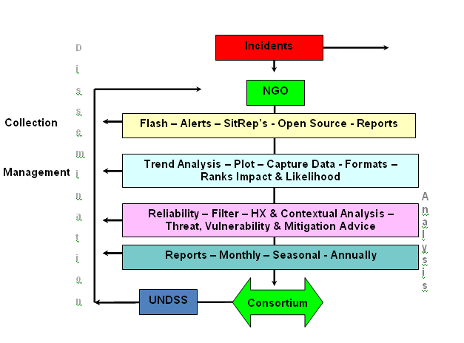
The collection portion of the Coordinating Model is still handled by NGOs and they report the incidents to the designated FSCO who then utilizes the other assets of the UNDSS and provides further management and dissemination, thus completing a Full Spectrum Collaboration Mechanism. The individual NGOs still have the internal responsibility of maintaining the vertical communications within their organization while applying appropriate guidance and policy on how to share information horizontally to the UNDSS in order for further and more detailed analysis. The closer that an analysis occurs to the problem the greater the likelihood of relevance and accuracy.

Consortium Collaboration Mechanisms
The European Initiative Security Forum (EISF), InterAction SAG, ICVA (among others) compose a collective of NGOs from their respective country or regions.

Recognized by the UN, they deal directly with the UNDSS, NGO Liaison Office in order to coordinate security efforts, information, training and other activities. If the UN NGO Liaison dealt with each NGO directly, the unit would be bogged down by the hundreds of emails and phone calls from individual NGOs alone. Instead the Liaison Office deals with the Security focal points of the consortiums in order to best facilitate the SLT program.

Represented in the model, in Green, the Consortiums have a few different functions. The consortiums have the CMD capabilities and provide Flashes, Alerts, Sitreps and other products to the members. They also conduct meetings, provide assistance, and act as advocates. Already mentioned is that they serve as the NGO representative to the UNDSS Liaison office as well.

Disaster/Evolving Circumstances
The Lebanon 2006, Lessons Learned as well as the Georgia 2008 Crisis both indicated that when conflict or disaster occurs in a region where development programs that are ongoing, it is vital to implement a security collaboration as close to the trigging event as possible. The InterAction Security Unit has identified that NGOs that are already engaged in development and humanitarian assistance are often overburdened by the emergency response because the staff members are often tasked with additional responsibilities become overburdened and the security and safety issues are not prioritized.

When the UN becomes engaged the local UNDSS will be overburdened by requests via SLT by individual NGOs, therefore the need for a single collaborative security office can assist in managing the information and service requests. The collaborative security approach is essential on the sudden onset of a disaster or evolving hostile environment. The collaborative mechanism would provide Flashes, Alerts, Sitreps and other products to the members that would clearly articulate the evolving risks. Additionally it would host meetings, provide assistance and act as advocates.

Conclusion
Full Spectrum Security Collaboration Mechanisms will facilitate the sharing of relevant information both horizontally and vertically and is intended to better facilitate information sharing and provide a cost sharing for the participating stakeholders. The visual representation that represents the informal, intermediate, or full-spectrum mechanisms can be used as an additional tool to better evaluate and assist in create collaborative structures.

The focal point of collaboration then becomes the “traffic light” of the information management process. The intersection of horizontal and vertical information networks effectively and clearly portrays an image (analysis) provided through the dissemination of information. The stakeholder can then interpret and compare analysis to their individual Security Risk Assessment in order to adjust activities and/or locations of their programs. Organizations participating in the collaborative effort will be able to provided a more focused image of the security situation and will assist the NGO in vertical and horizontal sharing important information.

Annex 1- Checklist of Collaboration Output

Collaboration Services

Output | Informal | Intermediate | Full-Spectrum
Text Alert | X | X | X
Telephone Tree | X | X | X
Email List | X | X | X
Meetings | X | X | X
Open Source Reports | X | X | X
Informal Sharing | X | X | X
Trend Analysis |  | X | X
Incident Plotting |  | X | X
Capture Data |  | X | X
Formats |  | X | X
Likelihood Rate |  | X | X
Impact Levels |  | X | X
Source Reliability |  | X | X
InfoSec Policy |  | X | X
Historical Analysis |  | X | X
Contextual Analysis |  | X | X
SRM Advice |  | X | X
Mitigation Advice |  |  | X
Training |  |  | X
Monthly Stat Report |  |  | X
Seasonal Analysis |  |  | X
Yearly Analysis |  |  | X

The above is a tool to use to assist in determining if a Security Collaboration Mechanism is Informal, Intermediate or Full Spectrum. Additionally, the same list can be used as a survey to determine the needs of a community in the creation of a new Collaborating Mechanism.

Acknowledgements

Michael O’Neill, Director of Security, Save the Children
Norman Sheehan, Director of Security, AED
Robert Macpherson, Cosantior Group
Trevor Hughes, Director of Security, IMC
Terry Wesbrock. Director of Security, IRD
Chris Williams, Director of Security, Plan International
Isaac Evans, Director of Security, Children’s Fund
Joe Donahue, CEO iMMAP
Chuck Connolly, iMMAP
Dr. Michael Gresalfi, DHS
Shawn Bardwell, USAID
Val Flynn, ECHO
Jim Bishop, Vice President, HPPT, InterAction
Josh Kearns, Associate Security Coordinator, Interaction
Tracy Jones, Intern, InterAction
Robert Painter, NGO Liaison, Untied Nations Department of Safety and Security
European Initiative Security Forum
InterAction Security Advisory Group

Annex 1 - Pakistan Security Collaboration (Informal)

MINUTES OF THE INGO SECURITY FORUM MEETING

HELD ON JUNE 17, 2008 AT 10:30 A.M.

Chaired by: Mr. Q

Present:

S.No. | Name | Organization
1.
2.
4.
3.
4.
5.
6.
7.
8.
9.

Agenda:

Item No.1 Introduction
Item No.2 Review of last meeting minutes
Item No.3 Debriefing by UNDSS
Item No.4 Updates from the Field
Item No.5 Threats to INGOs
Item No.6 Any other business.
Item No.7 Announcement of next meeting

Mr. Q, Security Manager, NGO A Pakistan opened the meeting and welcomed the participants. He requested all the participants to share their security information as much as possible so that the feeling of ambiguity could be eliminated and security determined on the appropriate level.

Item No.1: Introduction

- Mr. Q introduced himself as the Chair of the Forum and started with the introductions
- Introduction of the participants

Item No.2 Review last meeting minutes

The minutes of the last meeting were approved with few a minor changes

Item No.3 Debriefing by UNDSS

The Chair informed the Forum that as the UNDSS representative was not present hence the briefing could not be given.

Item No.4 Updates from the Field

- Mr. K shared that the UN offices were closed for the period of one week and no specific reason had been given. Speculation is that the French Cultural Centre had received a threat letter from the Taliban in Afghanistan hence they closed down their office indefinitely. The media had misinformed that all UN offices were closed indefinitely.
- NGA B received a threat letter from Khurram Agency that NGO B should not send their female staff to work in the fields. The work is currently suspended. An FIR was lodged however no further action has been reported.
- NGO C: Nothing to report
- NGO D: Nothing to report
- NGO E: Working in NWFP and Sindh areas. After the tragic incident at the NGO A, Area X office, they moved their regional office to Abbottabad. They had also received threat e-mail messages
- NGO F: It was reported that there has been a shortage of diesel in Mansehra and Peshawar since last week. It was shared that before / during the announcement of the new budget, gas stations adopt the practice of putting away the commodity for later use at a higher price
- NGO G: Nothing to report.
- NGO H: Nothing to report
- NGO I: Nothing to report. Resuming new program in Peshawar area. Not able to travel to tribal areas to reach the target population due to security reasons.
- Private Security Company A: Nothing to report.
- NGO J: Nothing to report.
- NGO K: It was reported that information could not be communicated between Peshawar and Parachinar. Their training has been postponed due to this reason. Two members from their organization were attacked during their mission. Fortunately none of the staff was hurt.
- NGO L: Received a threat email from Balochistan stating not to initiate any programmes in the Balochistan area. A discriminatory note stating that Punjabis were not welcomed.
- NGO M: They have restricted their movements in their field areas
- NGO N: Mr. Q mentioned he was planning to attend a meeting in Mansehra in order to get an update on the tragic incident of 25 Aug 2008. NGO N had approached various offices like the DCO, DG but the investigation is still on hold. No clear indication for the rationale has been established for this horrendous crime. It was suggested that the Interior Ministry should be contacted to obtain assistance in this regard.
- NGO O: Threat received that female staff in Battagram should not work in the fields or hospitals. The female staff has been removed until the elections on 26 June 2008.
- NGO P: Work progressing in Punjab and Islamabad areas. No threats. Their security officer is visiting various regions and districts where they are operational to assess and review security conditions prevailing and will report upon his return.

Item No.5 Threats to INGOs

- Some organizations have received threats in the last couple of weeks.
- Following the bombing in front of the Danish Embassy, where the UN office across the street was also wrecked, there were speculations that maybe the UN office could have been the real target.
- There is an open warning from the Al-Qaida that the UN offices will be targeted globally.
- It was shared that a technique could be adopted on most mobile phones to block unwanted calls from crank callers.
- The Pakistan Telecom Authority (PTA) has come up with a special number where one can register complaints against mobile numbers from which obscene or harassment calls are received. The Number is: 0800-550.
- It was also suggested that Cyber Crime Branch or the Interior Ministry could be contacted to determine/investigate the threat call/email received.
- The Long March ended peacefully however INGOs were concerned and closed their offices.

Item No.6 Any other business.

  - Permanent Security Focal Person: Mr. Q shared that it was not possible for NGO B to fund a full time Security Person for the forum as suggested in the previous meeting. He could continue in the capacity as the NGO B Security Coordinator and share the information accordingly. The forum appreciated and lauded his commitment and efforts to act as a Chair at the Forum.

  - INGOs working without registration: The forum was updated that several unregistered INGOs were compelled to close down their offices in Balochistan area. It was noted that all INGOs are to be registered with the Interior Ministry that would facilitate the INGOs in obtaining the NOC from the Home Department in initiating programs in various provinces in Pakistan.

  - Focal person to obtain security information from the police: It was suggested to having a focal person (like UN and some of the NGOs) who would visit and obtain security information that could be passed to the INGOs. The NGO C Coordinator informed the forum that the INGOs should observe a low profile with the police and perceived that getting too close to the police might have adverse reactions as they might start dictating and imposing upon the INGOs.

  - Sectarian violence in Hangu area: Four Shias were shot dead and random firing was reported. Kohat roads was blocked so that the Sunnis could not cross and start another sectarian feud. Hangu Bazar was closed down due to security reasons. In Dera Ismail Khan, four children were shot during the sectarian feud and the bodies were taken to Kotri for burial.

  - One day workshop: It was suggested that the Forum needs to conduct a one-day workshop so that everyone can be brought up to date on the current security situation. Each organization willing to participate could pay for their own representative and the workshop could be held at Serena Hotel or either in Murree or Nathiagali.

  - In-active members of the forum: It was suggested to encourage the inactive members to participate. Another proposition was to have an alternate person attending the meeting so that the information is conveyed to the organizations accordingly. Members that have discontinued their participation or are not interested should inform the INGO Security team of their withdrawal from the forum.

Item No.7 Announcement of next meeting:

The INGO Security Forum meeting was concluded with a thank you to all the participants. The next meeting will take place on Tuesday, July 1, 2008 at 10:30 a.m. at the NGA A

Annex 2 – SPAS (Full Spectrum – Weekly Report)

ABBREVIATED

Somalia NGO Security Preparedness and Support Program (SPAS)

Report Number – 22/08
Reporting Period:
21st – 27th May 2008
Notes
1. The Security Preparedness and Support (SPAS) Program is a concept of the Somalia Non-Governmental Organizations Consortium whose only concern is the safe provision of humanitarian and development Aid to the people of Somaliland and Somalia, therefore SPAS is an NGO project dedicated to the safety and security other Somali NGO Consortium members
2. SPAS is non-governmental. The SPAS Security Report is for the use o the Somalia NGO Consortium. The aim is to provide neutral and transparent information to facilitate security decision-making by Consortium members. SPAS assumes no responsibility for report accuracy, reliability or verification unless stated.
3. This report is the latest update on available security related information in Somalia and Somaliland. Situations may have changed and / or will change.
4. SPAS recommend that the NGO community use all best and available sources of information.
5. Security decision-making and protocols are the responsibility of subscribing NGOs. Security precautions are recommended at all times in accordance with respective organizational procedures.
6. SPAS do no provide security alert levels. The identification and provision o security alert levels/phases/thresholds are he responsibility o each organization.
7. This report is distributed for the information and benefit of the Somalia NGO Consortium.

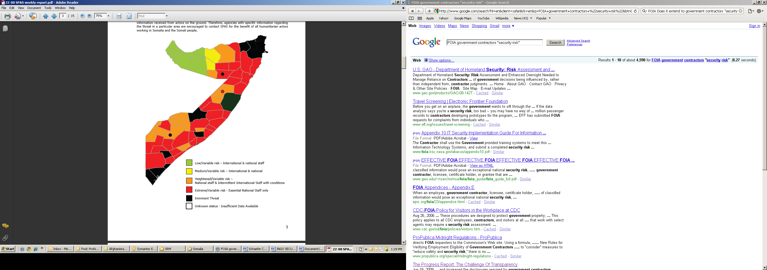 The sole purpose of the threat map below is to visually represent heightened areas of concern for humanitarian actors. The map represents only the opinion of NGO-SPAS staff and therefore is by no means comprehensive. Service users should acknowledge that this representation is only as good as information received from actors on the ground. Therefore, agencies with specific information regarding the threat in a particular area are encouraged to contact SPAS for the benefit of all humanitarian actors working in Somalia and the Somali people.
Executive Summary
The reconciliation effort to mediate between the “Alliance for the Liberation and Restoration of Somalia” (ALRS) and the TFG are expected to continue from 30th May, 2008 in Djibouti. Despite a preliminary first round of talks between the ALRS and the TFG earlier this month, the two sides remain profoundly hostile to each other and the risk of armed confrontation remains high in the foreseeable future.

Banadir, Middle and Lower Shabelle Regions:
The security situation once again deteriorated over the reporting period with insurgent attacks against TFG and its allies intensifying throughout central and southern Somalia with a profound number of casualties. Multiple attacks by AOGs against AMISOM, ET and TFG troops continued in Mogadishu city. The police commander for Lower Shabelle regional Division reportedly survived a landmine attack with TFG police attacked with a landmine in Medina. A Kenyan lecturer held hostage was released, nevertheless four other Internationals are reportedly being held within Mogadishu. Insurgent’s attacks against TFG and its affiliated troops are expected to continue within the regions.

Bay and Bakool Regions:
Tension remained high amongst the local population following the increased movements of AOGs who have seized control over all main strategic areas of Bay and Bakool regions except Baidoa town. There is a large contingent of insurgents within Baidoa who are expected to carry out more insurgency activities as declared by their leaders. IEDs and grenade attacks have become a common occurrence against ET/TFG forces. Incapacity of Government security forces to control the situation has led to gradual deterioration of security situation in the region with expansion of ICU/Al-Shabaab influence. Insurgents are reportedly issuing threat letters advising the local population to avoid Baidoa town due to imminent engagements with ET/TFG forces.

Hiraan and Galgadud Regions:
In Beletweyne town, AOG militias hurled a hand-grenade against ET troops prompting them to retaliate with heavy fire power. The local population has been exercising extreme caution due to fear of being caught in crossfire. There are reports that AOGs will be announcing independent administration in Bulo-Burte town against the TFG. In connection with this new dynamic ambush attacks against ET/TFG troops are expected to continue in the coming weeks despite heavy presence of ET troops. Galgadud region remained volatile with systematic assassinations, clan clashes and a piracy related incident where al-Shabaab militias engaged pirates after the ship was released.

Gedo, Middle and Lower Juba Regions:
The security situation remained calm in Gedo, parts of Middle Juba but tense in Lower Juba region. Reportedly Marehan clan and the ICU militants met and agreed that insecurity in Kismayo must be addressed at once. The aid community has come under intense pressure notably with LNGO staff being targeted reportedly for being suspected to be working as spies. In addition to clan related militia and ICU activities the GU rains in Middle and Lower Juba regions have made roads impassable. The aid community should plan carefully any convoys in these regions.

Following several towns takeover, ICU has scored a decisive victory against TFG within Lower Juba and established itself as the dominant authority throughout much of southern Somalia. Sources close to AOGs from Jilib District indicate that ICU was allegedly called upon to solve political differences between the Asmara group and the Al-Shabaab over Jilib and Kamsuma towns with reported death threats for any person appointed by either group. The prospects for a bitter showdown among the AOGs based in the area remain very real. This is assessed to affect the security situation in the entire region as echoed by AOG leader that they will fight and ensure all foreign forces leave Somalia.

Puntland:
The establishment of Puntland Security Management team, also known as the “Security Core Group”, comprising representatives from UN, INGOs, Minister of Security, Minister of Interior, Elders and Community Policing is a positive step towards security of the aid community. However, the presence of armed militiamen inside Bossaso and Galkayo has notably increased levels of insecurity in the towns during the reporting period. Law enforcement authorities continue to be targeted by armed militias with IEDs and assassination attempts. It is assessed that AOGs are setting foothold in the region in connection with the fighting between AOGs and clan militias in South of Mudug region. This will have a profound impact on security in Puntland in the foreseeable future.

Somaliland:
The security situation in Somaliland remained calm with meetings between the government and the opposition parties allegedly solving the electoral related dispute which has been continuing during the last two months. A landmine blew up a vehicle killing five passengers which underscores the potential danger landmines still pose in the region. The aid community is advised to take precautionary measures in all regions that have not been declared mine safe.
Statistical Data:
The statistical data below represent security incidents reported by NGO SPAS from 1st January 2008 to the 27th may 2008.

PRP: AOG Attack: 20 May 08, 17:00hrs, Siinka-Dheer (KM18), Mogadishu: 30 armed men attacked a TFG police check point located at KM 18 Southwest of Mogadishu (border between Mogadishu and Afgoi town). The AOGs took over control of the check point for about half an hour. During the incident re
c
PRP: RCIED Attack: 20 May 08, day time, Former Jaalle Siyad Military Academy, Hodan District: A roadside RCIED constructed from a land mine detonated in close proximity to ET and TFG forces while conducting patrol along the above mentioned location. During the incident 2 TFG and 2 ET troops were killed. TFG and ET re
n
PRP: Mortar shells Attack: 20 May 08, day time, Former defence Headquarters, Guulwadayaasha, former Spaghetti factory and Haile Barise buildings, Hodan and Yaqshid Districts: AOG fired 6 mortar

PRP: Hand Grenade Attack: 20 May 08, 19:12hrs, Horsed neighborhood (Suq-ba’ad Market), Yaqshid D
re
Assassination: 21 May 08, 08:30hrs, Medina Market, Medina District: Unidentified men armed with pistols
AOG Attack: 22 May 08, 18:25hrs, Herada Asluubta, Dharkenley District: AOG launched 3 attacks against ET troops based at the above mentioned location using m

Mortar Attack: 22 May 08, 18:00hrs, Former Spaghetti factory, Yaqshid District:

Assassination: 22 May 08, 18:20hrs, Bakara Market (Abu-Hureyra Mosque), Howlwadag District: A man was found dead
Hand Grenade Attack: 23 May 08, 11:45hrs, Banadir Secondary School, Hodan District: AOG hurled a hand grenade

RCIED Attack: 23 May 08, 12:00hrs, road between Km4 and Aden Adde Int. Airport, Medina District: A roadside RCIED constructed from a landmine detonated

Hand Grenade Attack: 23 May 08, day time, Florence hotel road junction, Wardhigley District: AOG launched a hand grenade attack

Mogadishu reportedly 4 TFG police were killed, 5 TFG police taken as hostages and robbed of tax money collected. enforcement arrived in the area and conducted house to house search in nearby areas arresting suspects. over mentioned locations reportedly killing one ET soldier at e former Ministry of Defence headquarters. district: Unidentified men hurled a hand grenade against TFG police base, no casualties were ported. shot and killed Mr.Abdullahi Mohamed Ali inside his store; reason behind the killing remains unknown. mortar shells and RPG-7s. One mortar shell landed at African village (Hodan District) killing an old man. AOG launched mortar attacks against ET troops prompting a fire exchange, no casualties were reported. 6 men armed with pistols shot and killed him. The motive behind the killing has not been established. against TFG and ET troops conducting patrol in the area; during the incident 2 civilians were wounded y to AMISOM envoy (Ugandan troops); during the incident 4 Ugandan soldiers were reportedly injured. ck against TFG forces based at the above mentioned caution; both sides exchanged small arms fire.

Annex 3- ANSO (Full Spectrum) Quarterly Report

